Analytical Problem Solving

- A banking system creates multiple account objects using different constructors (default, parameterized, and copy constructor).
- Analyze how object initialization differs in each case.
- Predict the order in which constructors are called when an account object is created from another object.
CODE:
#include <iostream>
#include <cstring>
using namespace std;

class Product {
int id;
char *name;
int quantity;

public:
// Parameterized Constructor
Product(int i, const char *n, int q) {
id = i;
quantity = q;
name = new char[strlen(n) + 1];
strcpy(name, n);
cout << "Parameterized Constructor Called\n";
}

// Copy Constructor (Deep Copy)
Product(const Product &p) {
id = p.id;
quantity = p.quantity;
name = new char[strlen(p.name) + 1];
strcpy(name, p.name);
cout << "Copy Constructor Called\n";
}

// Operator Overloading (+)
Product operator+(const Product &p) {
Product temp(id, name, quantity + p.quantity);
return temp;
}

void display() {
cout << "ID: " << id << ", Name: " << name
<< ", Quantity: " << quantity << endl;
}

// Destructor
~Product() {
delete[] name;
cout << "Destructor Called\n";
}
};

int main() {
Product p1(1, "Pen", 10);
Product p2 = p1; // Copy constructor
Product p3 = p1 + p2; // Operator +

cout << "\nProducts:\n";
p1.display();
p2.display();
p3.display();
return 0;
}

OUTPUT :

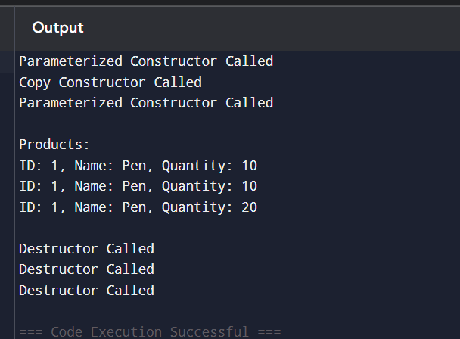

i)Difference in Object Initialization
Object initialization differs based on the type of constructor used:
🔹 Default Constructor
- Initializes object with default values.
- No arguments are passed.
- Used when an object is created without any data.
- Example concept: Account created with zero balance or empty details.
🔹 Parameterized Constructor
- Initializes object with user-defined values.
- Takes arguments to set values during object creation.
- Provides flexibility and proper initialization.
- Example concept: Account created with account number, name, and balance.
🔹 Copy Constructor
- Initializes a new object using another existing object.
- Copies all values from one object to another.
- Can perform shallow copy or deep copy.
- Ensures duplication of object state.

. Order of Constructor Calls (When Object is Created from Another Object)
When an object is created using another object:
Order of Execution
- First, the original object is created
→ Its constructor (default/parameterized) is called.
- Then, the new object is created from the existing object
→ The copy constructor is called.

- A software system manages inventory using a Product class that include A software system manages inventory using a Product class that includes:
- Parameterized constructor for product details
- Copy constructor for duplication
- Destructor for releasing resources
- Overloaded + operator to combine stock quantities
Analyze:
- The sequence of constructor/destructor calls when products are copied and combined.
- The role of operator overloading in simplifying inventory updates.
- Potential memory or logic issues if destructor is omitted.
CODE:
#include <iostream>
#include <cstring>
using namespace std;
class Product {
int id;
char *name;
int quantity;
public:
// Parameterized Constructor
Product(int i, const char *n, int q) {
id = i;
quantity = q;
name = new char[strlen(n) + 1];
strcpy(name, n);
cout << "Parameterized Constructor Called\n";
}
// Copy Constructor
Product(const Product &p) {
id = p.id;
quantity = p.quantity;
name = new char[strlen(p.name) + 1];
strcpy(name, p.name);
cout << "Copy Constructor Called\n";
}
// Operator Overloading (+)
Product operator+(const Product &p) {
Product temp(id, name, quantity + p.quantity);
return temp;
}
// Display Function
void display() {
cout << "ID: " << id
<< ", Name: " << name
<< ", Quantity: " << quantity << endl;
}

// Destructor
~Product() {
delete[] name;
cout << "Destructor Called\n";
}
};
int main() {
// Create product using parameterized constructor
Product p1(101, "Book", 20);
// Copy constructor
Product p2 = p1;
// Combine stock using + operator
Product p3 = p1 + p2;
cout << "\nProduct Details:\n";
p1.display();
p2.display();
p3.display();
return 0;
}
OUTPUT:
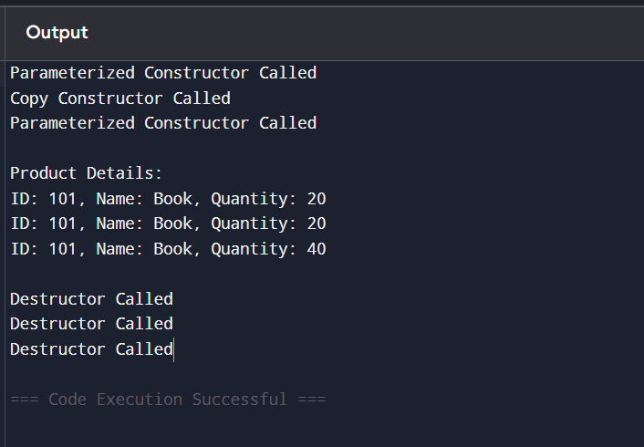

EXPLANATION:
When a product object is created, the parameterized constructor is called to initialize its details. If the product is duplicated, the copy constructor is invoked to create a new object with the same values. When two products are combined using the + operator, operator overloading simplifies the process by allowing direct addition, and a temporary object is created (again calling the constructor) to store the combined quantity. At the end of execution, all objects are destroyed in reverse order, and the destructor is called to release allocated memory. Operator overloading makes inventory updates easy, readable, and reduces coding complexity by avoiding separate functions. However, if the destructor is omitted, it can lead to memory leaks, wasted resources, and unstable program behavior, especially when dynamic memory is used.

3. A ShoppingCart system uses:
- Parameterized constructor for product initialization
- Copy constructor for cart duplication
- Destructor for clearing cart memory
- Operator + to merge carts
Analyze object lifecycle and memory management during cart merging operations.
CODE:
#include <iostream>
using namespace std;
class ShoppingCart {
string product;
int quantity;
public:
// Parameterized Constructor
ShoppingCart(string p, int q) {
product = p;
quantity = q;
cout << "Parameterized Constructor Called\n";
}
// Copy Constructor
ShoppingCart(const ShoppingCart &c) {
product = c.product;
quantity = c.quantity;
cout << "Copy Constructor Called\n";
}
// Operator + (Merge carts)
ShoppingCart operator+(const ShoppingCart &c) {
ShoppingCart temp(product, quantity + c.quantity);
return temp;
}
// Display
void display() {
cout << "Product: " << product
<< ", Quantity: " << quantity << endl;
}
// Destructor
~ShoppingCart() {
cout << "Destructor Called\n";
}
};
int main() {
ShoppingCart c1("Laptop", 1); // Parameterized
ShoppingCart c2 = c1; // Copy constructor
ShoppingCart c3 = c1 + c2; // Merge carts
cout << "\nCart Details:\n";
c1.display();
c2.display();
c3.display();
return 0;
}

OUTPUT:
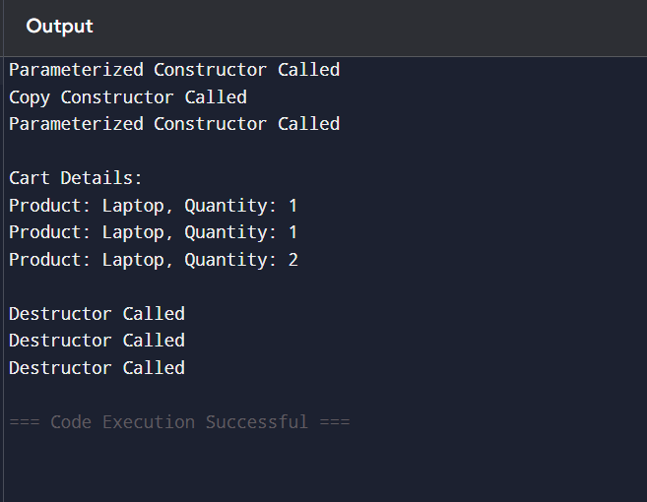

EXPLANATION:
The parameterized constructor initializes the shopping cart with product details. When a cart is duplicated, the copy constructor creates a new object with the same values. The + operator is overloaded to merge two carts by adding their quantities, which internally creates a temporary object using the constructor. At the end, destructors are called in reverse order to free memory. This ensures proper object lifecycle management and simplifies cart operations.

4. A retail company designs a class Product with the following features:
Parameterized constructor to initialize product ID, name, and quantity
Copy constructor to duplicate products during stock transfer
Dynamic constructor to allocate memory for product name
Destructor to release allocated memory
Overloaded + operator to combine quantities of two products
Tasks:
Analyze the sequence of constructor and destructor calls when:
A product is created, It is copied to another object, two products are added Explain how deep copy ensures correct behavior during stock duplication.
CODE:
#include <iostream>
using namespace std;
class Product {
int id, quantity;
string name;
public:
// Parameterized Constructor
Product(int i, string n, int q) {
id = i;
name = n;
quantity = q;
cout << "Parameterized Constructor Called\n";
}
// Copy Constructor
Product(const Product &p) {
id = p.id;
name = p.name;
quantity = p.quantity;
cout << "Copy Constructor Called\n";
}
// Operator +
Product operator+(const Product &p) {
return Product(id, name, quantity + p.quantity);
}
void display() {
cout << "ID: " << id
<< ", Name: " << name
<< ", Quantity: " << quantity << endl;
}

// Destructor
~Product() {
cout << "Destructor Called\n";
}
};
int main() {
Product p1(1, "Pen", 10); // Create
Product p2 = p1; // Copy
Product p3 = p1 + p2; // Add
cout << "\nProduct Details:\n";
p1.display();
p2.display();
p3.display();
return 0;
}
OUTPUT:
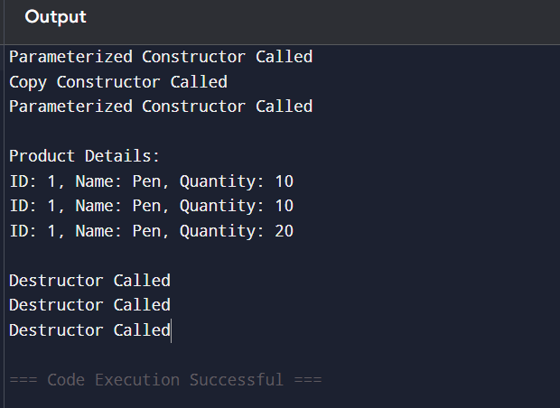

EXPLANATION :
When a product is created, the parameterized constructor initializes its details. When it is copied, the copy constructor creates a new object with the same values. When two products are added using the + operator, a temporary object is created to store the combined quantity. At the end, objects are destroyed in reverse order and the destructor is called. Using proper copying ensures each object is independent, preventing errors like data corruption or memory issues.

5. Consider banking application defines a class Account with:
Multiple constructor overloads (default, account number only, full details)
A copy constructor for transaction logs
A destructor for closing accounts
Overloaded operators:
+ → deposit
- → withdrawal
Tasks:
- Analyze how constructor overloading resolves initialization ambiguity.
- Trace object creation when:
  - Account is passed by value to a function
  - Account is returned from a function
- Evaluate risks if:
  - Copy constructor is not defined
  - Destructor is not invoked properly
- Analyze how operator overloading simplifies financial transactions logic.
CODE:
#include <iostream>
using namespace std;
class Account {
int accNo;
string name;
double balance;
public:
// Default Constructor
Account() {
accNo = 0;
name = "None";
balance = 0;
cout << "Default Constructor\n";
}
// Account number only
Account(int a) {
accNo = a;
name = "Unknown";
balance = 0;
cout << "Single Parameter Constructor\n";
}
// Full details
Account(int a, string n, double b) {
accNo = a;
name = n;
balance = b;
cout << "Parameterized Constructor\n";
}
// Copy Constructor
Account(const Account &a) {
accNo = a.accNo;
name = a.name;
balance = a.balance;
cout << "Copy Constructor\n";
}
// Operator + (Deposit)
Account operator+(double amt) {
return Account(accNo, name, balance + amt);
}
// Operator - (Withdrawal)
Account operator-(double amt) {
return Account(accNo, name, balance - amt);
}
void display() {
cout << accNo << " " << name << " Balance: " << balance << endl;
}
// Destructor
~Account() {
cout << "Destructor Called\n";
}
};
// Function (pass by value)
void process(Account a) {
cout << "Processing Account\n";
a.display();
}
// Function (return object)
Account createAccount() {
Account temp(200, "NewUser", 5000);
return temp;
}
int main() {
Account a1; // default
Account a2(101); // single
Account a3(102, "John", 1000); // full
process(a3); // pass by value → copy constructor
Account a4 = createAccount(); // return object
Account a5 = a3 + 500; // deposit
Account a6 = a5 - 200; // withdrawal
a6.display();
return 0;
}

OUTPUT:
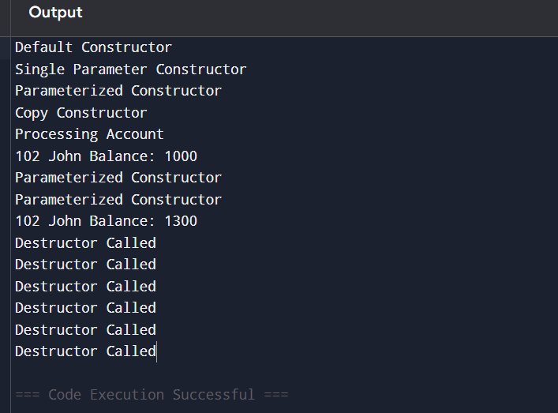

EXPLANATION:
Constructor overloading lets you create an account in different ways (empty, only account number, or full details), so there is no confusion while creating objects. When an account is passed to a function or returned, a copy constructor makes a separate copy to keep data safe. If it is not used properly, data may get mixed or incorrect. The destructor runs at the end to clean up objects. Operator overloading (+ and -) makes deposit and withdrawal easy to write and understand, just like normal math operations.

